**DAY-11**

**NAME: SUDHA SREELATHA**

**EMPID: 46255249**

**Smartforms**

Exercise 1 – Creation of Smartform:

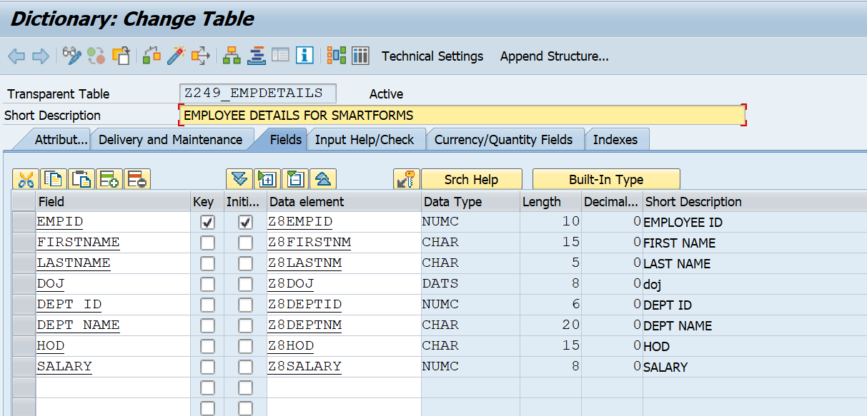

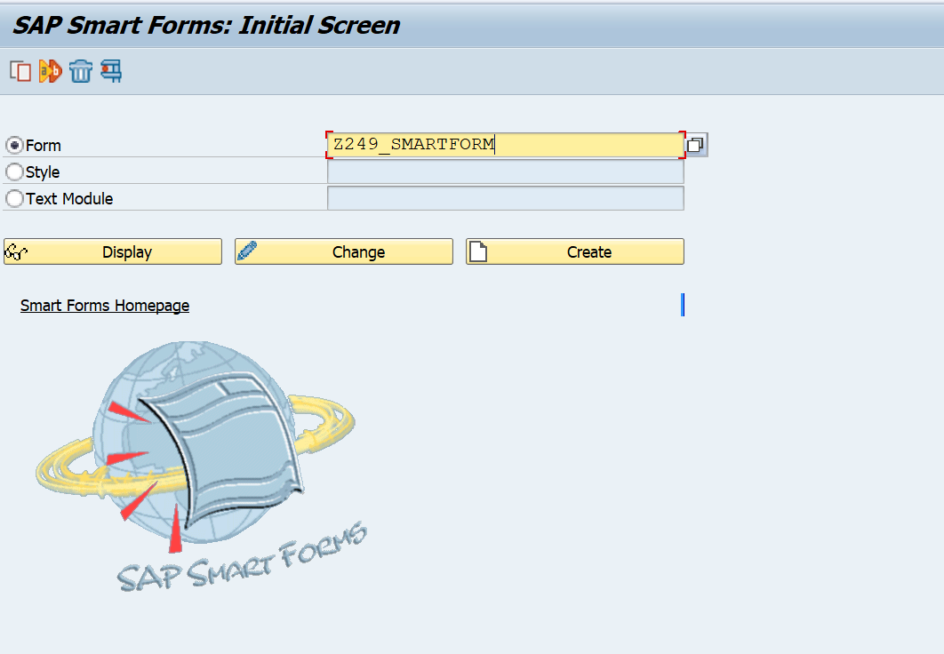

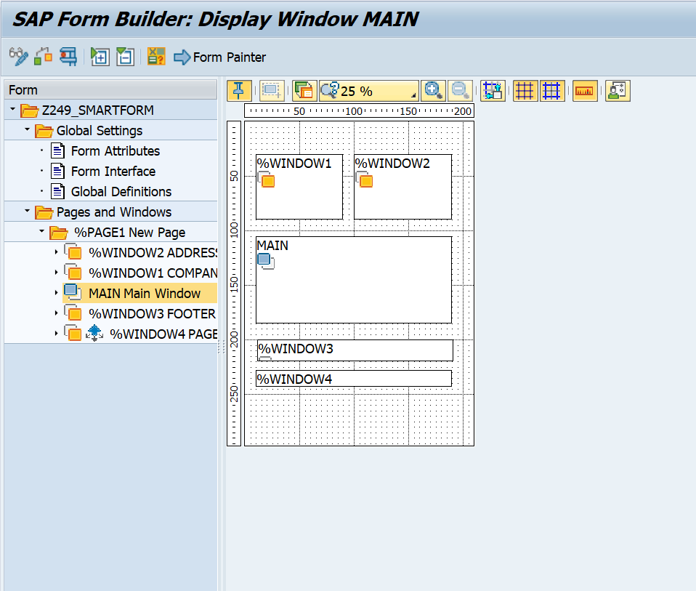

**Function Module:**

**Input:**

**Output:**

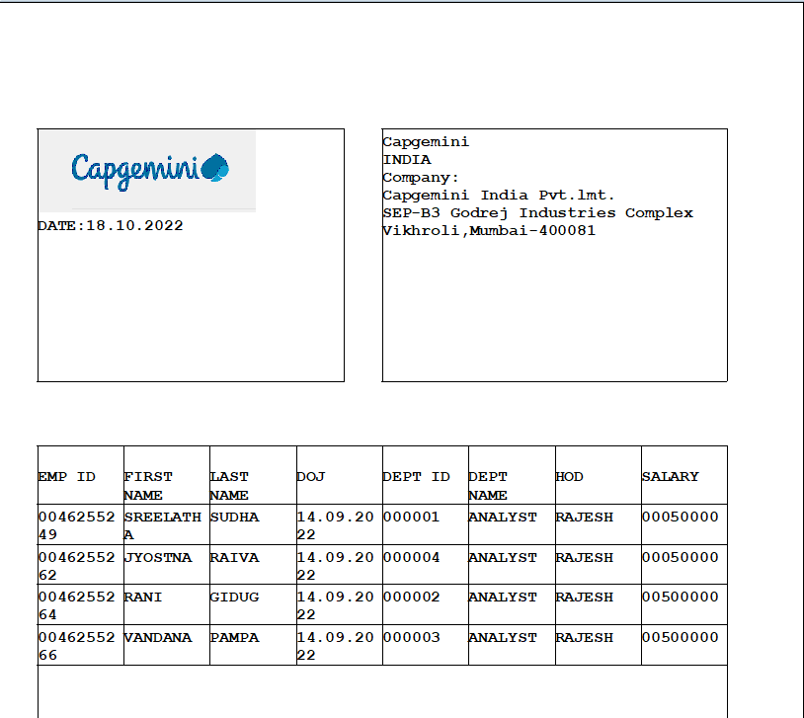

**Exercise 2 – Creation of Smart Style:**

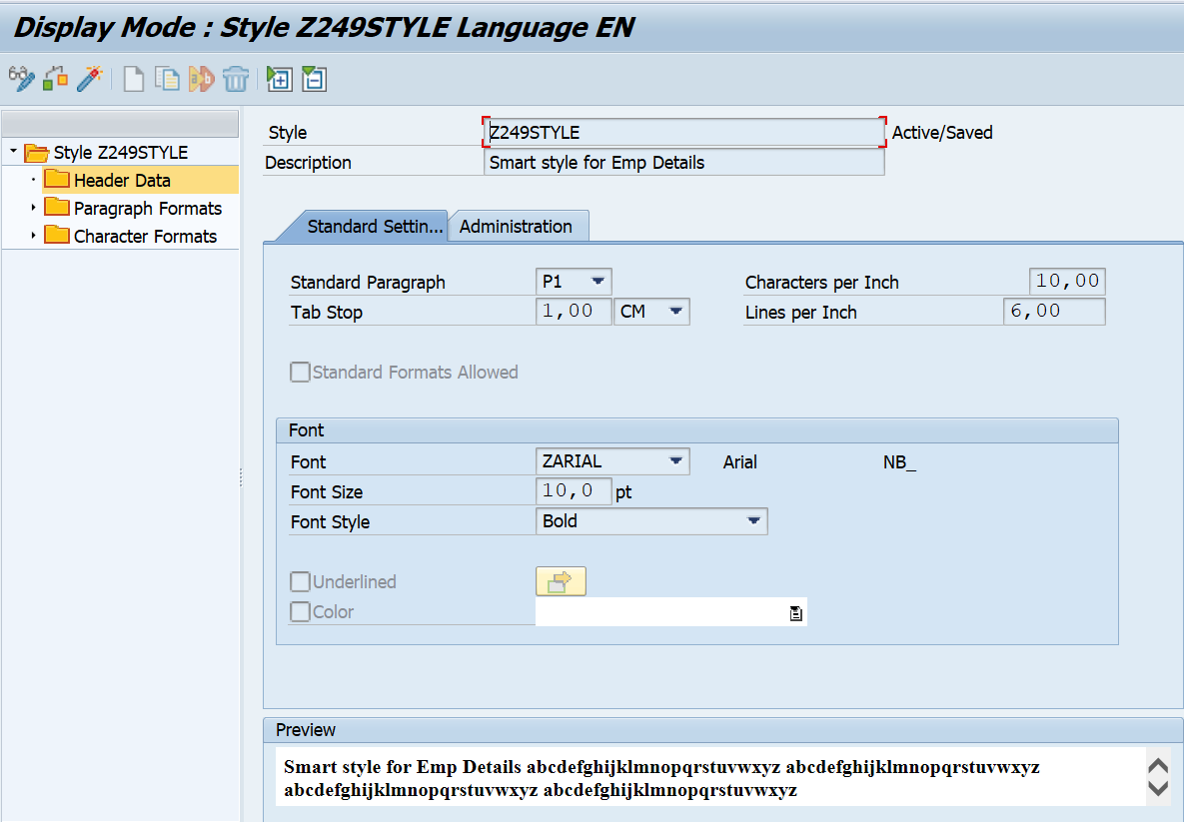

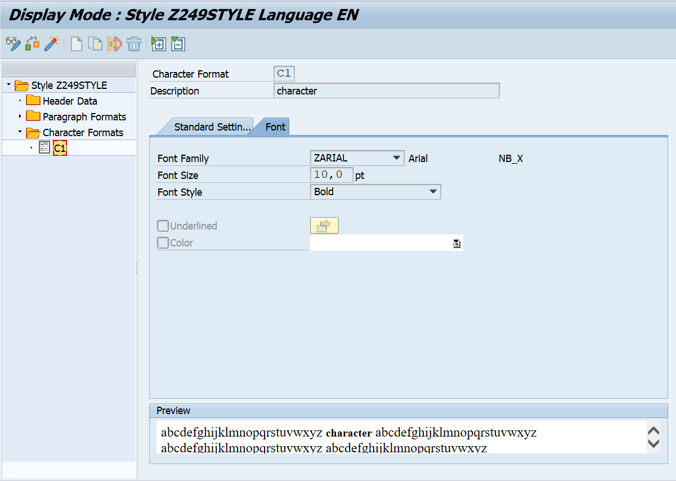

**Exercise 3 – Calling Smartform from the ABAP driver program**

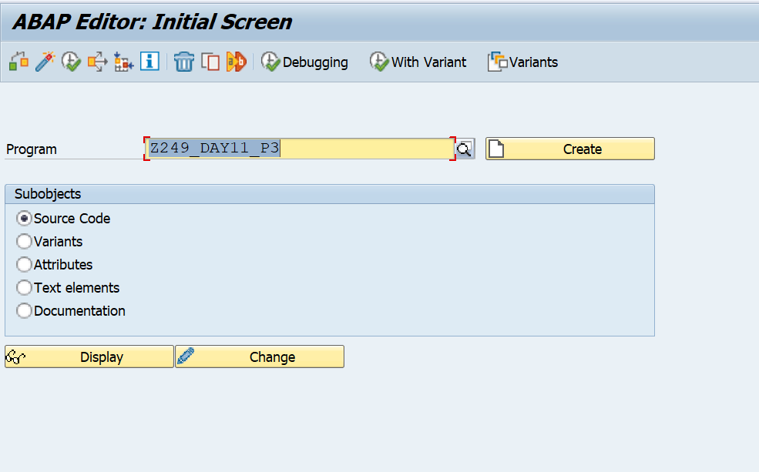

**Code:**

*&---------------------------------------------------------------------*  
*& Report Z249_DAY11_P3  
*&---------------------------------------------------------------------*  
* Description:                                                         *  
*                                                                      *  
* Author:                                                              *  
*                                                                      *  
* Create date:                                                         *  
*                                                                      *  
*&---------------------------------------------------------------------*  
* Modification log:                                                    *  
* -------------------------------------------------------------------- *  
* Date        User name      ID       Change Request   Case ref.       *  
*             Description                                              *  
*&---------------------------------------------------------------------*  
REPORT Z249_DAY11_P3.  
  
DATA : fm TYPE rs38l_fnam.  
  
*PARAMETERS: EMPID TYPE Z249_EMPDETAILS-EMPID.  
  
CALL FUNCTION 'SSF_FUNCTION_MODULE_NAME'  
  EXPORTING  
    FORMNAME                 = 'Z249_SMARTFORM'  
*   VARIANT                  = ' '  
*   DIRECT_CALL              = ' '  
 IMPORTING  
   FM_NAME                  = FM  
* EXCEPTIONS  
*   NO_FORM                  = 1  
*   NO_FUNCTION_MODULE       = 2  
*   OTHERS                   = 3  
          .  
IF SY-SUBRC <> 0.  
* Implement suitable error handling here  
ENDIF.  
CALL FUNCTION '/1BCDWB/SF00000764'  
* EXPORTING  
*   ARCHIVE_INDEX              =  
*   ARCHIVE_INDEX_TAB          =  
*   ARCHIVE_PARAMETERS         =  
*   CONTROL_PARAMETERS         =  
*   MAIL_APPL_OBJ              =  
*   MAIL_RECIPIENT             =  
*   MAIL_SENDER                =  
*   OUTPUT_OPTIONS             =  
*   USER_SETTINGS              = 'X'  
* IMPORTING  
*   DOCUMENT_OUTPUT_INFO       =  
*   JOB_OUTPUT_INFO            =  
*   JOB_OUTPUT_OPTIONS         =  
* EXCEPTIONS  
*   FORMATTING_ERROR           = 1  
*   INTERNAL_ERROR             = 2  
*   SEND_ERROR                 = 3  
*   USER_CANCELED              = 4  
*   OTHERS                     = 5  
          .  
IF sy-subrc <> 0.  
* Implement suitable error handling here  
ENDIF.

**Output:**

